# Teenaa koutou katoa,

Welcome to Cambridge Primary School.

Here at Cambridge Primary School we have;

* A welcoming school, where all pupils and families can feel part of our community
* A safe school, where all pupils, staff and families feel safe in our environment
* A positive learning environment where every teacher has the right to teach and every child has the right to learn.

This booklet will help you, as a new family, to learn a little more about Cambridge Primary School. We aim to keep you well informed. This booklet, our friendly office staff, a fortnightly electronic communication (CPS newsletter), our School app, Facebook page and website, are the communication strategies we employ to help you stay connected with Cambridge Primary and the activities taking place. Each parent is also able to log on to their child’s Linc-Ed account, which gives access to school reports, updates and school account information.

Your child will be well taught by excellent staff and will learn in a warm, secure and safe environment. Our friendly and welcoming staff and students will help ensure your child settles in happily and quickly. We hope you will feel free to contact the class teacher, your child’s team leader or myself if you have any queries or concerns.

If you have interest in becoming an active member of our school community there are a few ways you can do this; as a parent helper, a PTA member or as a Board of Trustees member, to name a few. I am sure that you will find participation in school life very rewarding.

Again, welcome to our school and please do keep in touch.

Ngaa mihi mahana



Regards,

C:\Users\Kate.p\AppData\Roaming\PixelMetrics\CaptureWiz\Temp\10.jpg

Mike Pettit Michelle Jenkins

**PRINCIPAL** **CHAIRPERSON BOARD OF TRUSTEES**

**Introduction**

Cambridge Primary School is situated in the Cambridge town CBD. We are on the corner of Duke Street and Wilson Street opposite the Fire Station. We are a zoned school.

**Motto**

Quality – Tradition – Innovation

**Vision**

Creating powerful students through quality, tradition and innovation.

**Cambridge Primary School Values**

|  |  |
| --- | --- |
| * Integrity * Feeling safe and secure * Honesty * Hauora / wellbeing * Sustainability / enviro * Active Learning * Effective stewardship * Collaboration * Reliability * Fairness * Co-operation * Caring & Compassion * Independence | * Perseverance * Respect * Loyalty * Tolerance * Leading opportunities for all akonga * Diversity and inclusion * A thinking classroom * Being the best I can be * High expectations * Relationships * Engagement and communication & * Turangawaewae – a sense of belonging / ownership. |

**Cambridge Primary School Enrolment Zone Details**

* Both sides of the road are included in the home zone unless otherwise stated.
* Starting at number 1735 Cambridge Road (SH1) take a direct line to the Waikato River.
* Follow the river along its northern side to a point opposite Alpers Ridge.
* Cross the river here and head along Alpers Ridge to the roundabout with Cambridge Road.
* All of Cambridge Park and River Garden homes are included.
* Follow Cambridge Road, east towards Pope Terrace.
* Follow Pope Terrace to Wordsworth Street. Marlowe Drive, Drayton Place, Fletcher Place and Eliot Place are included.
* Follow Wordsworth Street to its end. Burns Street numbers 1-14 and Shakespeare Street numbers 1-76 are included.
* From the eastern end of Wordsworth Street, follow the river east to a point in line with 391 Tirau Road (SH1).
* From 391 Tirau Road, take a direct line to 307 French Pass Road. From here take a direct line to the northern end of Smart Road.
* From the northern end of Smart Road, take a direct line to the intersection of Maungakawa Road and Fencourt Road.
* Follow Maungakawa Road to Thornton Road, west to Victoria Street. Maclean Street numbers 1-8 are included. Tiaki Way is also included.
* Follow Victoria Street, north to Clare Street. Dr Todd Court is included.
* Follow Clare Street to the end, taking a direct line to the northern end of Kelly Road.
* From Kelly Road, take a direct line to number 60 Peake Road then head back to the starting point at 1735 Cambridge Road.

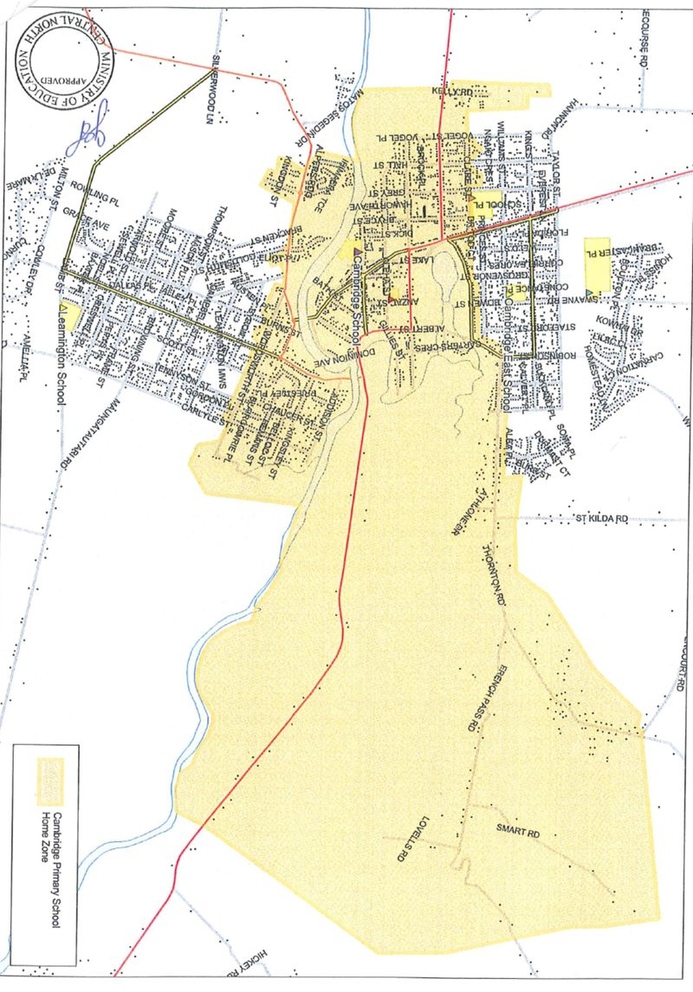

**OUR HISTORY- 1866**

Soon after the establishment of Cambridge as a military settlement in 1864, there were around 200 children in the families of the early military settlers who urgently required the provision of a school.

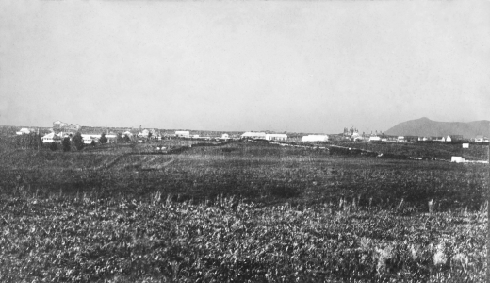The first school was established at the Redoubt in Fort Street in 1866. However, with the movement of troops to other areas, the school was discontinued. In 1869 Cambridge was declared an educational district by the Auckland Provincial Council. In the same year, a town settler Mr William Cunningham called together a few of the townspeople and suggested they apply to the authorities to use the disused hospital building which stood at the foot of the Duke Street hill as a school.

The present school site was used from 1874, and the old hospital building was transferred here to become the nucleus of the new school. The school grew rapidly and the roll in 1880 was 161 students.

On 2nd July 1883, the High School department was formed on the same site with a roll of 23 students. In order to qualify for the High School, students had to be over the age of 12 years of age and agree to pay a fee of eight guineas per annum. The department closed in 1887 due to low attendance but was reopened 20 years later in 1907 with 17 pupils.

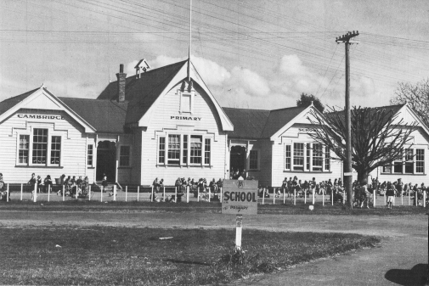A further classroom, teacher’s room and porch were erected in 1904 and in 1905 a separate classroom was built for the high school students. In 1909, a manual block and technical block were built. By 1910 the primary roll was 209. By 1917 the roll was up to 327; 82 children were crowded into one room in the infant department and 99 were taught in the Standard 3/4 room. Five new rooms were added in 1921 to accommodate the roll growth. In 1947, the roll had climbed to 486. In this year the first PTA was formed.

In 1952 the roll had increased to 560. With overcrowding, cold corridors were being used as classrooms. At this stage the Form 1 & 2 students were transferred to the High School as an Intermediate Department. After 1961, the High School relocated to the site at Bowen Street and the Intermediate Department (now the Middle School) remained at Clare Street. During the 100 years from 1866-1966 over 12,000 children had received their primary education at this school.

It is interesting reading some of the recent past history. Mr Bernie Hennessy, Principal from 1968-1970 recalls collecting the walnuts and drying them on a wire wove bed (a practice still followed years later!) and he recalls the dissatisfaction of the female staff whose toilet was located directly opposite the main entrance. Whenever it rained, the toilet roof leaked badly, so an umbrella was placed for handy use. A most difficult assignment to answer the call of nature and hold an umbrella at the same time!

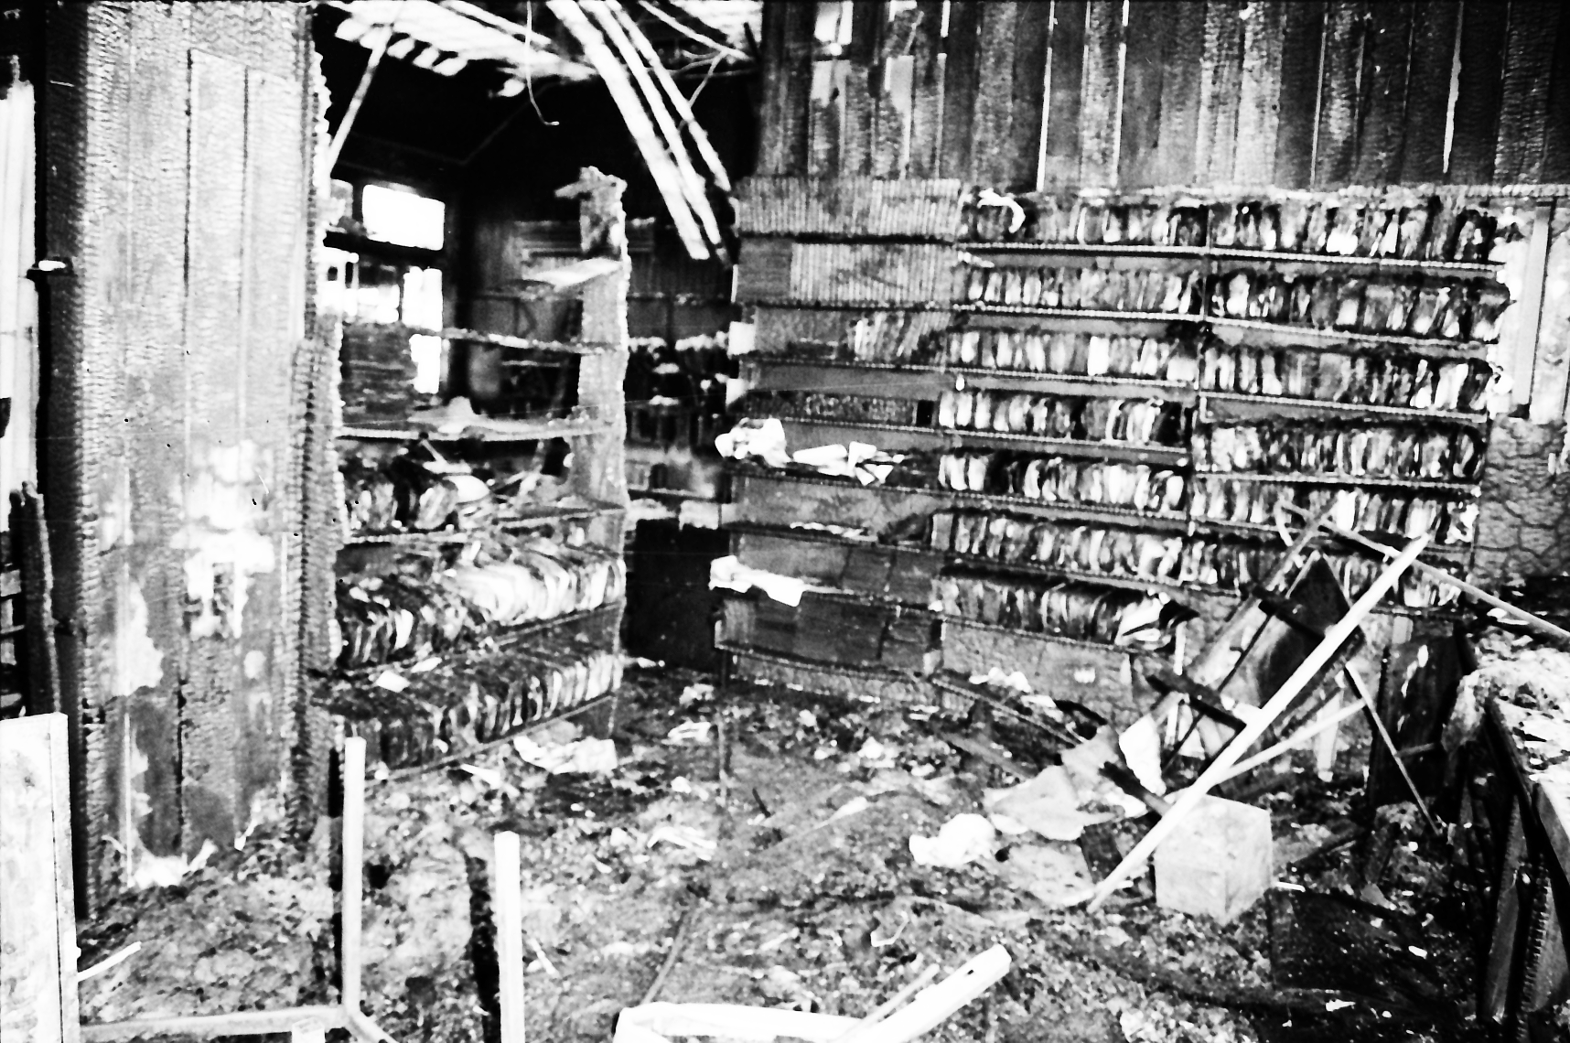Mr Keith Illingsworth (1971-1984) recalls the first major remodel. An open meeting on December 6th 1978, resolved that the exterior of the building be retained and the interior remodeled to modern educational standards. This was completed in May 1981.

Mr Denis Raines (1985-1999) had to deal with a major “Black Spot” in the school’s history. Two classrooms and the Library were devastated by arson on the 31st of October 1986. The historic building refused to submit totally to the fire and all classrooms were restored to their former condition.

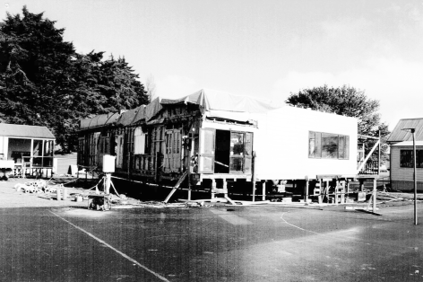Under the management of Pat Poland (1999-2001), the school administration area was modernised (no umbrellas needed!). This was completed in July 2001. In this same year a large hall was also relocated onto the site.

From October 2001 until April 2008 Mrs Donna Donnelly (Hudson-Owen) was Principal. Under Donna’s management the hall was given a fresher look on the interior with paint, kitchen and toilet facilities were built and the floor replaced. In 2007 the sandpit and swimming pool were removed from the front of the school and replaced with the Learning Pathways Area.

Under the current management of Mr Mike Pettit (2008-Present), 2009 saw the interior of the hall completely refurbished, the exterior reclad and the hall frontage brought in line with the character look of the main building. In 2011 an additional junior classroom was built, the staffroom was given a fresh new look and two additional offices were built. 2012 saw a new school uniform introduced. Also in 2012 the school frontage was upgraded with the planting of buxus hedging and the clearing of the river area at the back of the school was cleared, creating the Stanaway Reserve.

In April 2014 the Alison Wallis Room was moved to become a transition room as part of Batten Syndicate. This has been relocated to where the PE shed was originally. Over the 2014/2015 Christmas break two further classrooms in the Rutherford Syndicate block were built and the existing three classrooms upgraded, in keeping with the schools heritage look.

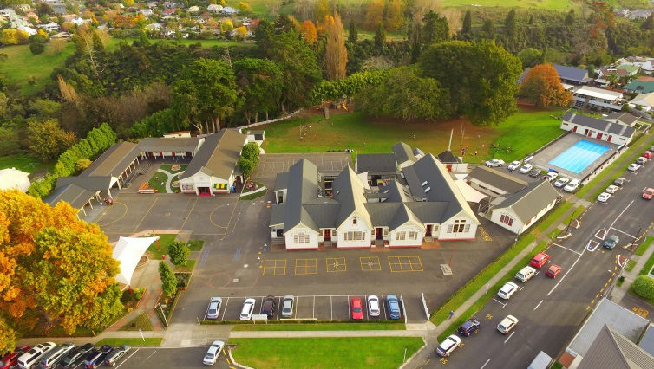A 25 metre pool and building was completed in 2015. Although not officially opened until the 2016 sesquicentennial celebrations (150 years) In 2015 the students and staff undertook a vision mapping project. There have been some amazing projects including the Rutherford syndicate outdoor area upgrade, a giant clock facing the field, Batten play area, redevelopment of Blake yard, line markings, a drinking fountain and a flying fox. During the 2015 Christmas break an upgrade of the A Block took place. 2015 also saw Cambridge Primary School awarded the Silver award for Enviro Schools.

As mentioned previously we celebrated our sesquicentennial, 150-year reunion of Cambridge Primary School 26th – 28th February 2016. In 2017 we added a scooter and bike track, along with 40 bikes.Further information about the history of Cambridge Primary and the local area can be located at our local museum or the school.

**CAMBRIDGE PRIMARY SCHOOL STAFF 2020**

|  |  |  |
| --- | --- | --- |
| **Principal:** Mike Pettit | **Deputy Principal 1:** Nic Pettit | **Deputy Principal 2:** Gareth Haman |

|  |  |  |  |
| --- | --- | --- | --- |
| **Rutherford Syndicate** | | | |
| Room 1 | Sacha Marnoch | Teacher | Y5/6 |
| Room 2 | Anna O’Brien and Hannah Buchanan | Teacher | Y5/6 |
| Room 3 | Adam Poka | Teacher | Y5/6 |
| Room 4 | Charlott Bayliss & Hannah Buchanan | Team Leader / Teacher | Y5/6 |
| Room 5 | Di Kelly | Teacher | Y5/6 |

|  |  |  |  |
| --- | --- | --- | --- |
| **Hillary Syndicate** | | | |
| Room 6 | Kimberley White | Teacher | Y3/4 |
| Room 7 | Carmel Stock & Hayley Shaw | Team Leader/ Teacher | Y3/4 |
| Room 8 | Julie Wallace | Teacher | Y3/4 |
| Room 9 | Rob Skeldon | Teacher | Y3/4 |
| Room 12 | Taryn Jago - Sutton | Teacher | Y3/4 |

|  |  |  |  |
| --- | --- | --- | --- |
| **Blake / Batten Syndicate** | | | |
| Room 10 | Karen Jack & Gareth Haman | Teacher | Y1/2 |
| Room 11 | Petalla Kapua & Charlotte Jamieson | Teacher | Y1/2 |
| Room 14 | Amy Crawford & Charlotte Jamieson | Teacher | Y1/2 |
| Room 15 | Anna Wren & Maria Vetisse | Teacher | NE/Y1 |
| Room 16 | Colleen Bredenbeck | Teacher/ Team Leader | NE/Y1 |

|  |  |  |  |
| --- | --- | --- | --- |
| **Release Teachers and Arts Teachers** | | | |
| Jen George | SENCO | Ange Hay | Science/STEAM |
| Alex Dowdle | Challenge & Extension | Sacha Marnoch | Music |
| Jani Clements | Reading Recovery | Hannah Buchanan | Visual Art |
| Deborah McElwee | Assessment Teacher | Kate Henstock | Dance/Drama |
| Sue Lyon | Being My Best | Sandrine Pryor | French |
|  |  | Kelly Ngaru | Maori |

|  |  |  |  |
| --- | --- | --- | --- |
| **Support Staff** | | | |
| Kate Dye | Principal’s Secretary/ BOT Administrator | Amber-Lee Jarrett | Learning Assistant |
| Hayley Elvines | Front Office Administrator | Hayley Booth | Learning Assistant |
| Sandy McKenzie | Payroll & Four Peaks Administrator | Sue Hoyle | Learning Assistant |
| Kate Paine | General Administrator & HR | Andee Brown | Learning Assistant |
| Dr Ann Easter | International Student Director / ALLiS Executive Officer | Mariet Storm | Learning Assistant |
| Sharon Burns | Librarian | Helen Fuller | Learning Assistant |
| Marie Dale | Sports Administrator | Ian Lewell | Caretaker |
| Kim Foss | ESOL | Allan Jackson | Cleaner |
| Nevis Stanaway | Learning Assistant |  |  |

|  |  |  |  |
| --- | --- | --- | --- |
| **Four Peaks After School / Swim School** | | | |
| Helen Fuller | Four Peaks Supervisor | Anamieke Pettit | Four Peaks Assistant / Hall Cleaner |
| Taasha Connon | Four Peaks Assistant | Sorrel Brydon | Four Peaks Assistant / Hall Cleaner |
| Hayley Booth | Four Peaks Assistant | Anica Van Den Berg | Four Peaks Assistant |
| Daniel Wilkinson | Four Peaks Assistant | Tom Coston | Four Peaks Assistant |
| Phoebe Pettit | Four Peaks Assistant | Sharon Mosen | Four Peaks Assistant |
| Natalie Mckenzie | Four Peaks Assistant | Melissa Crampton | Four Peaks Assistant |

|  |  |  |  |
| --- | --- | --- | --- |
| **Four Peaks Swim School** | | | |
| Mike Easter | Swim Instructor |  |  |
| Kate Morrison | Swim Instructor | Marie Dale | Swim School Administrator |

|  |  |  |  |
| --- | --- | --- | --- |
| **Four Peaks Coffee Bar** | | | |
| Grant Jack | Manager |  |  |

**2020 SCHOOL HOURS & TERM DATES**

**School Day Begins** 8.45am **Term 1** 3rd Feb – 9th April

**Morning Interval** 10.30am – 10.50am **Term 2** 28th April – 3rd July

**Lunch** 12.30pm – 1.30pm **Term 3** 20th July – 25th September

**School Day Finishes** 3.00pm **Term 4** 12th October – 15th Dec, 12:00 noon

Children are welcome at school from 8.30am **not before**. Staff begin arriving from 7.30am. Please note they are onsite to prepare for the school day, not to mind children. Children are not permitted unsupervised on the school site before 8.30am. All children to be off site by 3:15pm unless booked into After School care. The school roll sits between 380 - 420 students.

**GOVERNANCE**

Cambridge Primary School is fortunate to have dedicated and hardworking parents on the Board of Trustees. The Board meet twice a term to discuss, review and plan governance related issues. Boards of Trustee meetings are open meetings and parents / caregivers are invited to attend.

Board of Trustee meeting minutes are a public document and are on display in the foyer. The School Charter, Strategic Plan and School Policies are always available to parents at the school office and on the school website.

**CAMBRIDGE PRIMARY SCHOOL BOARD OF TRUSTEES**

Board Members Michelle Jenkins - Chairperson

Andrew Twaddle

Nicola Cronin

Shaun Baker

Calum Jamieson

Principal Mike Pettit

Staff Trustee Kate Paine

Secretary Kate Dye

## 

## THE A TO Z OF HOW THINGS HAPPEN AT CPS

**Accidents & sickness**

Minor accidents are treated in the school medical room, but parents are contacted if the accident is of a more serious nature. From time to time children get sick and our office staff may contact you if there is a problem. Please ensure your child is well enough to return to school if they are experiencing illness. Medicine can be administered at school, please see the office to complete a Medication Form. It is important that the school has up-to-date information of contact phone numbers and email addresses. If your child is unwell please keep them home. When unwell children attend school it affects our staff as well as other students. We appreciate your cooperation with this.

**Assemblies**

Parents are very welcome to attend the assemblies. Parents are notified through the school newsletter and website of assembly days and times. Generally, a full school assembly is held on even school weeks eg. Weeks 2, 4, 6, 8 and 10 at 2.15pm – and Syndicate assemblies are held on odd weeks throughout the term.

**Attendance/ absences**

The Education Act governs all enrolment and attendance. All pupils are expected to attend school every day the school is open. If for any valid reason your child or children need to be absent from school for any other reason other than sickness or family commitments, permission must be sought from the Principal in the first instance.

All non-attendance must be explained. All absences need to be reported by a parent / caregiver before 8.45am. You can contact us via the school app, using the absences link on the home page of the website ([www.cambridgeprimary.co.nz](http://www.cambridgeprimary.co.nz)).Please ensure you include your child/ren’s full names and room numbers with your preferred communications. These communications save us having to make a phone call to you to ascertain the whereabouts and safety of your child.

[](http://www.google.co.nz/url?sa=i&rct=j&q=&esrc=s&source=images&cd=&cad=rja&uact=8&ved=0ahUKEwiC9ferv_LRAhXFErwKHZlIAKYQjRwIBw&url=http://www.ola.school.nz/WebSpace/151/&bvm=bv.146094739,d.dGo&psig=AFQjCNGDwxH1fjEkbBH6dV6C6MONBo9VRg&ust=1486162070320775)

**Banking**

Cambridge Primary provides a banking facility through the ASB bank. Banking can be done any day and is collected on a Friday. Bank books are placed in the ASB box at the office. Information is available from the school office.

**Bicycles/Scooters**

We recommend that only Year 5 and Year 6 students ride bicycles to school. All cyclists must wear safety standard approved helmets. If parents wish their children to ride to school, please ensure they know the rules of the road and correct procedures. If children are traveling over the high level bridge, we recommend that they get off their bicycles and walk on the footpath. Bicycles need to be in a sound, safe condition. Children are to walk store them in the bike racks during school hours.

**Before & After School Care and Holiday Programme - Four Peaks**

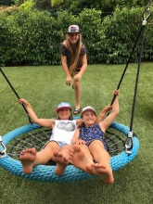This service is owned and operated by the Cambridge Primary School Board of Trustees and is operated out of the school hall. The Four Peaks OSCAR Programme provides a safe, secure and fun environment for children 5-13 years old. Four Peaks is an OSCAR approved programme. The morning programme opens at 7:30am each school day and finishes at 8:30am, when children are then welcomed into class. The afternoon programme operates 3:00pm to 5:30pm.

Everyone has lots of fun; children may do art and craft, play games inside and outside and much more.  Homework supervision is available on request (Monday to Thursday) and normally takes place in a separate classroom.  Afternoon tea is provided.  We offer a choice of wheatmeal or white bread with a selection of spreads. Fresh fruit is supplied along with water.  We do our best to cater to children with special dietary requirements.

Four Peaks also deliver a very popular **Holiday Programme**, offering a variety of crafts, sports, swimming and friendship. The Holiday Programme sees the children venturing out once a week for a day trip (usually Wednesday). Now, you can complete your days’ work knowing that your child is being cared for in a safe and friendly environment. We look forward to getting to know your child. If you wish to enrol your child/ren please check our holiday programme booking system on the school website or see the office for more information.

**BYOD (Bring your own device)**

CPS acknowledges that the 21st century is increasingly complex, global and networked. A “Bring your own device” (BYOD) supports out tamariki to develop the skills and dispostions required to succeed in modern teaching enviroments. The NZ ciriculium reflectsthis need with a strong focus on promoting digitally capable, global citizens. The children in Year 3-6 classes all have GAFE (Google) accounts to access, store, create and reflet on their learning, from both school and home. Each child will be able to share their learning progress with their families. The school will continue to provide a number of devices in all classes but we encourage students to bring their own device. For more information please email Carmel Stock on carmel@cambridgeprimary.co.nz

**Cellphones/Smart Watches**

We do not encourage cell phones or smart watches at school. If a device is bought to school and is either lost or damaged CPS takes so responsibility for this and will not spend time trying to find or fix them. Any distraction to your child’s learning or the learning of others will be dealt with through the normal disciplinary processes.

**Class Organisation**

The school is organised into four main teams, Batten, Blake, Hillary and Rutherford.

Some classes are composite. Team Leaders in each area help the Principal with the school organisation and the placement of children in the most appropriate class for the child’s needs.

**Communications**

Fortnightly an electronic newsletter with school happenings will be emailed home. It would be great if you could read through with your child. If you are not receiving this email, please let us know so that we can check that we have your correct information. Hard copies are available from the school office newsletter wall or available on the school website under the ‘newsletter’ tab.

Copies of notices that have been sent home will be available on the school website under ‘Parent Information’.

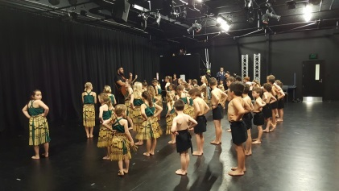

**Cultural groups**

We run a Kapahaka Group led by staff and a trained facilitator. We do welcome parents and Whanau to support this or come and join in.

**Curriculum**

Our teachers provide exciting teaching and learning experiences in all of the essential learning areas of the National Curriculum: Science, Mathematics, English, Technology, Social Studies, Health and Physical Education, Arts, and Languages. Our teachers are also committed to their responsibility to cater for special abilities and run the appropriate programmes. We offer STEAM (Science, Technology, Engineering, Arts and Math) programme on a 6 week rotation and Challenge and Extension which runs for the whole school year for years 3-6.

**Cybersafety**

When your child enrolls at Cambridge Primary School they will be required to complete a Cybersafety Use Agreement Form. Once completed your child is then entitled to use computers and other electronic devices at school. During the enrollment process we will also seek your permission to use your child/ren’s image in our online and printed materials. The school does its best to enhance learning through the safe use of ICT.

**Dental treatment**

A Dental Therapist is based at Cambridge Middle School. If you have any concerns regarding treatment, please phone (07) 823 9385.

**Donations**

We ask each family to pay a school amenities donation and a paper fee donation annually to enhance the learning opportunities the school is able to provide. At the start of the school year you will receive an invoice with the amount that the Board of Trustees deem fair as an annual contribution. The current donation of $160.00 has been in place since 2007. We can assure you this donation will be put to good use to buy those valuable extras for the benefit of all students. During the course of the school year new families enrolling will be asked to pay for a proportion of the annual donation. School donations are able to be partially claimed back through your tax return for the following tax year, using an official school receipt which can be generated at the time of payment.

**Education outside the classroom (EOTC)**

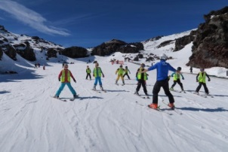Team and class trips and camps play a very important part in the school programme. Consent forms are always included when you are notified of an out of school activity. It is important that these are signed and returned to the school. There will often be a charge for these activities. All children in the school are expected to attend camp. The Blake and Batten camp is a sleep over at school, or in tents, and all parents are welcome. New students will be sent an EOTC form when they start at CPS. This covers EOTC activities while your child attends CPS unless you advise us otherwise.

Please read, sign and return to your teacher as soon as possible.

****Parents are always needed and appreciated when helping with trips, camps or sporting activities. Please be generous with your time if at all possible. A ballot system or CV of skills may be required if the required parent numbers are oversubscribed. It is not possible to have pre-schoolers on trips. All parents/caregivers are required to have an up to date police check completed with the results back to the principal before camp starts.

**Emergency procedures**

The school practices emergency procedures; in particular fire, earthquake and lockdown drills throughout the year so that in the unlikely event the children and staff know what to do. We would encourage families to work out similar emergency procedures for the whole family when at home. Our post evacuation procedures include a link with the Local District Council’s Civil Defence

Co-ordinator.

**English as a second language students**

Being a multi-cultural school enriches us!. We have a number who are ESOL students. We receive funding from the Ministry of Education to teach these children English and we employ a learning assistant to work alongside them. The learning assistant is responsible to the classroom teacher and our SENCO.

**Enrolment of students**

We have a school enrolment zone, details of which can be found on the school website and at the back of this prospectus. We require all enrolments to be submitted online. This can be done at [**https://forms.linc-ed.com/?school_id=1702**](https://forms.linc-ed.com/?school_id=1702). At the top of this online enrolment form you will find the supporting documentation we require. You can email these documents to [office@cambridgeprimary.co.nz](mailto:office@cambridgeprimary.co.nz) . Students enrolling directly from overseas need to present passports or other documentation as evidence they are in New Zealand legally. Student Visas must be shown.

**New entrants**

This Cambridge Primary School Board of Trustees has implemented a cohort entry policy. This means some children, depending on when in the term their birthday falls, will be able to start school before they turn five, while others will have to wait until after their fifth birthday. Ministry of Education guidelines state that as a parent, you can delay your child’s start up until their 6th birthday.

We see great benefits in cohort entry; such as, children starting together rather than arriving into a new school environment individually throughout a term so children are able to attend our transition to school programme as a collective. Midterm dates are determined by the Ministry of Education. If your child’s birthday falls before the midterm date they can start at the beginning of that term however if their birthday falls on or after the midterm they are required to start at the beginning of the following term. Please see below a table illustrating this explanation.

|  |  |  |  |  |
| --- | --- | --- | --- | --- |
| **2020 Term Dates** | **Start of Term** | **End of Term** | **Weeks in Term** | **Cohort Entry Midterm Dates** |
| Term 1 | Fri 3rd Feb | Thur 9th April | 10 weeks | Mon 9th March |
| Term 2 | Tue 28th April | Fri 3rd July | 9 weeks | Tue 6th June |
| Term 3 | Mon 20th July | Fri 25th Sept | 10 weeks | Mon 24th August |
| Term 4 | Mon 12th Oct | Mon 15th Dec | 10 weeks | Mon 16th November |

New entrants have many adjustments to make in the transition from pre-school to school. The physical size of the school, the number of people, a more structured day, conforming to school guidelines and the increased effort expended in learning. All these challenges can leave them extremely tired at the end of the day. We offer preschool visits to help your child transition. Please enquire at the school office for details.

Parents often ask “what does my child need to know before they start school?” We offer a “Flying Start to School Pack” specifically designed to help your child get off to a good start. The pack includes things such as; letter and number cards, counting beans, a small reader about the school and much more. The pack is $5 and is available from the school office.  The feedback about the packs has been very positive from both parents and children. If you have any questions or queries regarding the information regarding cohort entry, please contact the school office.

**Enviro School**

Our school is a Green Gold Enviro School. We have a dedicated group of children and teachers (we would love parents or grandparents to join us.) who are enthusiastic about learning about the world around us. We value people and the environment at Cambridge Primary School. As part of this we also have a community food stand where you can trade produce or buy our chickens fresh eggs.

**Fitness**

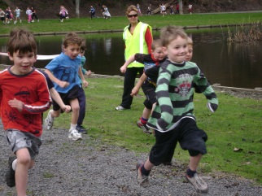Children’s physical fitness and well-being is very important in the learning process. Each team runs a regular fitness programme for the children. We encourage families to play their part in being active and engaged in the outdoors.

**Green and gold**

Green and gold are our school colours. The colours have a purposeful meaning for our school. The green relates to being user friendly, an environmental focus, along with the importance of the school trees. The gold colour is for high achieving with high goals. These colours also now tie in with the town’s motto: Town of Trees and Champions.

**Hall**

Our school is fortunate to have a Hall on site from which we hold assemblies, outside school classes and other whole school activities. The hall can be hired out to the community for a small cost. Please contact the school office if you wish to hire the school hall.

**Health nurse**

Our Public Health Nurse is employed by Health Waikato and visits the school on a fairly regular basis. If you wish to access her services, please feel free to do so through the Principal or school office. Hearing and Vision testing is carried out regularly and parents are advised if there is a problem. The Ear Clinic can be contacted on 07 838 3565 extn: 22189.

**Health curriculum**

Board of Trustees is required to consult the school community on the Health Curriculum at least once every 2 years. Cambridge Primary School will consult in a variety of ways. These will be advertised through the newsletter.

**Homework**

We believe homework is important; not just for its own sake but also as a means for parents and children to share with each other what is happening within school. Teachers will advise parents of what is expected at each level. In the Junior classes the children will bring home a reading book or poem each night. Homework should never become a cause for arguments in the home. The school also recognises the busy lives of families. Please see your child’s teacher if a change to normal homework is required at certain times of the year. Homework is useful when school related activities are consolidated and enriched with the support and encouragement of parents.

**Houses**

We operate a House System, and all children enrolled are placed in a House. Children are kept with their siblings. The Houses are: Charisma (black), Sir Tristram (yellow), Young Quinn (green) and Zabeel (white). Children are encouraged to gain “points” for their house in a variety of school activities (both academic and sport) - the house with the most points throughout the year wins the “House Shield” which is on display in the office. House colours are to be worn on certain school sports days.

**Interviews/reporting/information sharing**

At the beginning of each term a team Information newsletter will be sent home to parents/caregivers. These inform you of programmes, expectations, targets and goals. It is not a formal interview time however teachers are present. Also in Term One, arrangements are made for Parent/Teacher Interviews so that you can discuss your child’s learning with their teacher. This is a valuable contact with the school. A second interview is held early in Term Three.

A report on your child’s progress will be sent through LincEd in terms 2 and 4.

Parent/Teacher relationships are very important for the progress of children. If you would like to see the class teacher outside those formal interview times, please phone or see your child’s teacher to arrange another suitable time for you both. Our doors are always open. Curriculum Information evenings are also held from time to time. You will also find teachers outside at 3pm so this can be a good chance to catch up or organise a more formal time to meet.

**Kea crossing & road safety**

[](https://www.google.co.nz/url?sa=i&rct=j&q=&esrc=s&source=images&cd=&cad=rja&uact=8&ved=0ahUKEwisxKe0wvrRAhXGHZQKHct6AbQQjRwIBw&url=https://www.pinterest.com/pin/568086940470936385/&bvm=bv.146094739,d.dGc&psig=AFQjCNGH6swUh1y282Gp9HY5zm8kv_ESOA&ust=1486437754362183)This is patrolled by children with adult supervision between 8.30am – 8.40am, and 2.55pm – 3.10pm. We welcome offers of assistance from our community. Children are urged to go straight home after school if not attending Four Peaks After School Programme. Any arrangements to go to friends’ houses after school must be made with friends and parents the night before. Parents when walking children are required to use the kea crossing and reinforce our road safety procedures especially when collecting their children after school. We are always looking for adult volunteers to assist us

**Key competencies**

Our programme enhances the values we teach at Cambridge Primary School. Please see the website for complete an outline of the programme.

**Learning Needs**

Our school recognises that there are children who require special assistance to meet their educational and social needs. This includes children with special abilities. We have a Special Needs Co-ordinator (SENCO) Mrs Jen George and we are committed to providing assistance within the resources and time available. To contact Mrs George please email jen@cambridgeprimary.co.nz

**- Dyslexia**

Dyslexia describes a pattern of learning difficulties related to: reading, spelling and written language. These difficulties are unexpected, as dyslexia influences specific areas of learning, and is not related to an individual’s general level of intelligence.

While the pattern of learning difficulties varies from individual to individual, typically dyslexia is related to problems with developing awareness of and processing sounds in language (called phonological processing).

The ability to link letters and words to sounds is necessary to develop fluent and accurate reading. Other differences in brain structure and function may also contribute to dyslexia and affect abilities in other areas such as: mathematics, planning and organisation. As dyslexia is a life-long condition, early identification is important to provide effective and appropriate support for learning.

**-Dyspraxia**

Developmental dyspraxia (also known as Developmental Co-ordination Disorder and the Clumsy Child Syndrome) is a neurologically based disorder of motor function, affecting the gaining of new skills and the carrying out of those already learned. It affects children in different ways at different stages of development, and is inconsistent – as if sometimes information is `put away’ in the wrong drawer.

It is not a behavioral problem, not an overt physical disability, and may not even be visible – until the child tries to learn a new skill, or to repeat a learned one out of context.

**-Dyscalculia**

This is a term used to indicate a lack of ability to perform mathematical calculations. This condition is associated with neurological dysfunction. Students with dyscalculia have difficulty processing numbers. It is a significant learning disability, often showing up in students with other learning difficulties, which can mask the dyscalculia. It is not related to any lack of intellectual ability.

At Cambridge Primary School we wish to support any child displaying the above traits and their families, so the student may better access the curriculum. We do not require an official diagnosis to adapt your child’s programme.

**-What’s next?**

There is thought to be a genetic component to the above 3 conditions. Please let us know through the enrolment form if you, your child or anyone in your child’s family have/had traits of any of Dyslexia, Dyspraxia or Dyscalculia. We have a Leadership Group made up of parents and staff that provide guidelines for best practice. We also have a Parent Group to support our families and provide current information. Our will be in contact if you have ticked any boxes regarding dyslexia, dyspraxia or dyscalculia.

**Library**

Our computerised School Library is an important learning centre at Cambridge Primary School. Your support as caregivers/parents would be appreciated to ensure the care and return of our library books. We also visit our Town Library. Within the school library is also a parents’ library which is focused on helping parents bring up children and teenagers.

**Lost property**

A lost property cupboard is situated between the toilets in the Blake Courtyard. It is available for parents to view during the school day. **Please name all your child’s clothing.** Any unnamed garments (or illegible name), will become school property at the end of each term, as no name means no proof of identity. No discussions will be entered into. All unnamed lost property will be laundered and official school uniform will be placed into the uniform cupboard where it will available to anyone for purchase. All unnamed ‘non uniform’ items will be given to charity where feasible.

**Lunches**

[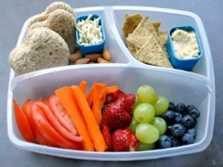](https://www.google.co.nz/url?sa=i&rct=j&q=&esrc=s&source=images&cd=&cad=rja&uact=8&ved=0ahUKEwjRxJWnw_rRAhWKVrwKHReIAUkQjRwIBw&url=https://www.pinterest.com/brainectomy/whats-for-lunch-box/&bvm=bv.146094739,d.dGc&psig=AFQjCNEIQm-_MA10QRZaP9jEOUDHfwR-zg&ust=1486437934047527)Please provide a healthy lunch and a drink for your child. We discourage foods and drinks with high sugar, food colouring and preservative content as many children react to these and become hyperactive. This in turn can impact on your child’s learning and that of others.

A sausage sizzle takes place each Friday. Orders for the Friday sizzle can be made at the school hall on Friday mornings from 8.30 to 8.45am. Prepayment for the full term is also an option via Internet Banking or at the front office. These payments are non-transferable, non-refundable.

**Money sent to school**

If money is required for any school activity, a notice will be sent home detailing the amount required and explaining the purpose of the expense. All monies brought to school should be sealed in a named envelope. For your convenience student payment envelopes can be found at the front office, on our Tuatara deposit box. Please complete all details requested, one envelope per child, per payment. No monies are to go through the classroom.

**Parent / Caregiver concerns**

Please let us know as soon as possible if you have any concerns. Do not let things fester. Keep the communication lines open. Make contact with teachers, senior staff or the Principal and hopefully we can work out any issues together.

**Parent involvement**

The school has an open door policy for parents visiting their children. As a courtesy though, please make an appointment if you wish to discuss your child’s progress and arrange a mutually suitable time for you and your child’s teacher. It is inappropriate to “pop in” and expect the teacher to stop what they are doing and talk to you during class time.

We do appreciate the level of support given by parents. Teachers would welcome any offer of help. Needs of teachers vary from class to class and levels of the school. Assistance may be given accordingly;

* Help with the reading programme
* Help with school trips, camps, sporting outings
* Library assistance
* Coaching/ Managing of school sports teams
* Working bees
* Perceptual Motor Programme (PMP)

**Parent Teachers Association (PTA)**

We have a vibrant PTA who play an integral role in fundraising projects that benefit the school and the children. New parents, parents of existing children, whanau and extended family are welcome to come along to our monthly meetings. We welcome your input! With your help, initiatives and support, we can continue to make our school a better place, and provide the very best for our children. Our PTA is supported by the Board of Trustees and staff, and has raised funds for a number of school amenities.

**Parking**

[](http://www.google.co.nz/url?sa=i&rct=j&q=&esrc=s&source=images&cd=&cad=rja&uact=8&ved=0ahUKEwjY8YS-w_rRAhWKipQKHS3LAiEQjRwIBw&url=http://www.taupodc.govt.nz/our-services/parking-information/where-to-park/Pages/where%20to%20park.aspx&bvm=bv.146094739,d.dGc&psig=AFQjCNFI0sPbHYNjdiZuOGrLyLVa1oEZQw&ust=1486438062494555)Unless in an emergency, parents are asked not to enter the school grounds in vehicles during the school day which includes Before and After School from 7.30am – 5.30pm. For the safety of our children, we also ask parents/caregivers not to use the staff parking areas to drop off or collect children. There are designated 5 minute drop off and pickup parking spaces on Duke Street.

Parking is a real problem especially on a wet day. We really encourage parents to use the parking area between Bridges Church and the Prince Albert in Hally’s Lane. A safe walkway runs to the right of Bridges Church. Please remind your child to use the walkway and not to cross through the church’s carpark. Bridges Church carpark is a private carpark so please do not park there.

Please park considerately so that our neighbours can easily access their driveways, even if parking for short periods of time. From time to time the Police and Waipa District Council visit school to ensure parents/caregivers are legally parking around the school, when dropping off and picking up children from school. A disabled carpark is located in the staff carpark at the rear of the school or the first carpark on Wilson Street.

**Personal property**

The Board of Trustees and Staff accept no responsibility in the case of loss or damage to valuables or articles brought to school. While all reasonable care is taken and efforts made to find property lost, the responsibility rests with the owner. We ask children to keep small toys, play things and cell phones/smart watches at home – many are alike, they are difficult to name, can be easily lost and may be a distraction to others.

**Photographs**

Class photographs are taken once a year. There is no obligation to buy. Cultural/sports photographs are also taken throughout the year.

**Principal Awards**

At the end of each term classroom teachers acknowledge 3 recipients per class who to receive a Principals Award. These are handed out at the last assembly of term. Each child receives a certificate, chooses a book that is to be donated to the school library and they attend a Principal’s award party.



**Productions/Dance**

Productions and dance evenings are held at Cambridge Primary School. Due to the hours involved, the frequency is determined after consideration of all events on the school calendar, however we generally alternate year on to year off.

**Reading recovery**

When children turn six, their reading is tested, and if teachers feel that children would benefit from one-to-one instruction they are recommended for a support Reading Programme. Parents will always be kept informed about their child’s progress. In 2020 we have two reading recovery teachers catering for approximately 16 children throughout the school year. There are limited spaces in this programme. Please do not hesitate to ask questions if you do not understand the process.

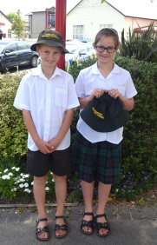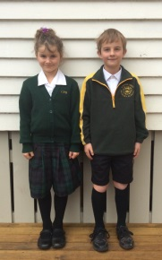**School uniform**

Our Formal school and PE uniforms are compulsory. Children are required to arrive and depart school in **complete formal uniform** including sandals or shoes. PE uniform may only be worn during school hours, to sporting events or if going to the Four Peaks After School Care programme.

Uniforms can be purchased from Image Apparel, Empire Street Cambridge, 07 827 8912. They are the sole provider of any new school uniform.

Winter uniform is worn from Queen’s Birthday weekend to Labour Day, and summer uniform from Labour Day through to Queen’s Birthday. The school requires that during the summer months, all children wear sunhats for outdoor activities, at intervals and lunchtimes. Sun hats can be purchased from the front office. Summer months are defined as the period commencing Term 4 through to the end of Term 1. The school office has a secondhand shop

Please ensure that all items are clearly named. Any unnamed garments (or illegible name), will become school property, as no name means no proof of identity. No discussions will be entered into. All unnamed lost property will be laundered and official school uniform will be placed into the uniform cupboard where it will available to anyone for purchase by way of koha or donation. All unnamed ‘non uniform’ items will be given to charity.

**Sport @ CPS**

We encourage all children to become involved in one or many sports. Children have access to equipment from the PE gear shed available at break times. Sporting skills are taught in all codes by teachers through a balanced Physical Education programme. We employ a Sports Coordinator to organise our winter and summer sports teams. Winter sports in Term 2 and 3 are strengths of the school, with Hockey, Rugby and Netball. We have also recently introduced Lightening Lacrosse to the winter programme.

CPS teams play under the banner of Cambridge Primary School in the colours of green and gold. Soccer and cricket are played in the local club competitions.

During summer (Term 1 and 4) we offer Miniball, Flippaball (Water Polo), Lightening Lacrosse and Touch rugby. Registrations are taken online via Enrolmy. Keep an eye out in communications for registration dates and information or visit [enrolmy.com/cambridge-school](http://www.enrolmy.com/cambridge-school)

Our Physical Education programme embraces swimming, athletics, cross-country, and gymnastics. Inter-School competition across many sporting codes is part of the planned School Sports Association’s annual programme. If you, as parents/caregivers have special skills or desires for coaching and/or managing please do not be shy, get involved. All sport related enquiries can be made through sport@cambridgeprimary.co.nz

**Staff**

Cambridge Primary School employs only the best staff. At the end of each year parents are advised as to the placement of their children for the New Year. If you have any questions regarding placement, please contact the school office. The final decision in classroom placements ultimately is with the Principal.

[](http://www.google.co.nz/url?sa=i&rct=j&q=&esrc=s&source=images&cd=&cad=rja&uact=8&ved=0ahUKEwin_ZCUyfrRAhUCjpQKHTodCj4QjRwIBw&url=http://www.hamwest.school.nz/&bvm=bv.146094739,d.dGc&psig=AFQjCNGttF_f_-m9UOKjPir0nt41uHbnYQ&ust=1486439584976210)**Stationery**

Towards the end of a school year you may order your child’s stationery pack for the following year via OfficeMax. You can purchase a pack online and have it delivered to your home at a time that is convenient to you.   Students who arrive at the beginning of the school year can also order online. We will have a small supply of stationery packs for payment and collection at the school office for new students arriving throughout the school year. Please order via: [www.myschool.co.nz/cambridgepri](http://www.myschool.co.nz/cambridgepri)

**Swimming**

All children are expected to take part in the swimming programme. Please send a note or call the school if for any reason your child is unable to go swimming on a particular day. Please send togs and towels in a named waterproof bag.

We offer after school swimming lessons in our school pool during terms 1 and 4. Bookings are via Enrolmy: [enrolmy.com/cambridge-school](http://www.enrolmy.com/cambridge-school). Please contact [sport@cambridgeprimary.co.nz](mailto:sport@cambridgeprimary.co.nz) for details.

**Swimming pool keys**

Pool keys are available for purchase by CPS families and the wider community. Keys allow access outside school hours in Term 4 and 1. Please contact the school office for details.

**Trophy awards**

The criteria can be found in each classroom. Trophies are awarded to encourage children to aspire for excellence. The Trophy Criteria can also be found on the website.

### CPS WARRANT OF FITNESS FOR CHILDREN

Our students need;

**Plenty of sleep**

We can’t work with children who have watched too much television or stayed up late – at least 10 hours sleep for primary children is recommended.

**To be well fed**

To learn effectively children need a balanced diet with regular meal times – breakfast is essential for a six hour school day. Children need both mid-morning and lunchtime food and drink. Fresh fruit, sandwiches, filled rolls, yoghurt, muffins and cereal bars are ‘brain food’ for your children. No fizzy drinks, lollies or chocolate please.

**To be secure**

Our pupils come from caring homes. They need reassurance and realistic expectations from their parents and/or caregivers. Children learn best when they are supported and nurtured in their educational growth.

**To have a positive attitude**

If children expect good things to happen at school in all areas of learning they will have a keen and sparkling approach to their day. Don’t dull this with worries, fears and niggles! But please do let the classroom teacher know of any emotional considerations. We encourage children to always do the Right Thing at the Right Time for the Right Reason.

**To have the correct gear**

Be ready for the day. Have such things as stationery, lunch, library books and swimming togs. We do not encourage children to ring or contact you to bring things – we encourage independence and self-management.

**To be on time – the school day starts at 8.45am**

Children are disadvantaged if they arrive late. Lateness can lead to students who are not ready for the day’s learning and playing. It can also interrupt other children’s learning.

**Welfare of children**

Children are not to leave the school grounds at any time during the day without permission. If you need to take your child from school during school hours you must sign your child out via the iPad register in the office. You will then be issued a purple slip which needs to be handed to the classroom teacher before you take your child/ren off site.

Parents / caregivers of children who are going to be late or absent should notify the office before 8.45am. This can be done personally, via a note, a phone call, email or our website. Your child then needs signing in at the office on their arrival.

Your child’s safety is our prime concern. We therefore strongly promote positive behavior in our school. This means that no one person has the right to abuse any other person. No one person has the right to intimidate any other person in any way. It also means that it is “okay to tell” if you are being bullied.

